|  |
| --- |
| Circle Language Spec: Commands |

## Command Reference in a Diagram

The principle of command references is explained in the article *Command Reference*. The current article demonstrates the expression of it in a diagram.

A command reference is displayed in a diagram as a diamond or square connected to another diamond or square with a solid line.

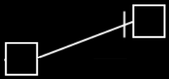

It does not matter whether it is squares or diamonds, because the only difference between a square and a diamond, is that a square can *not* be executed and a diamond *can*.

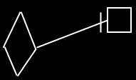

Direction of the line must be indicated with an access mark, unless the line is going outwards:

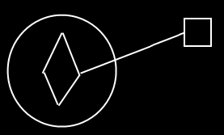

You can not execute an active command object through an inactive command reference.

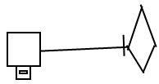

But with an executable reference to an inactive reference to an executable command you *can* execute the command object again.

